**Grassland Birds in Ontario**

# Balancing Conservation and Agriculture

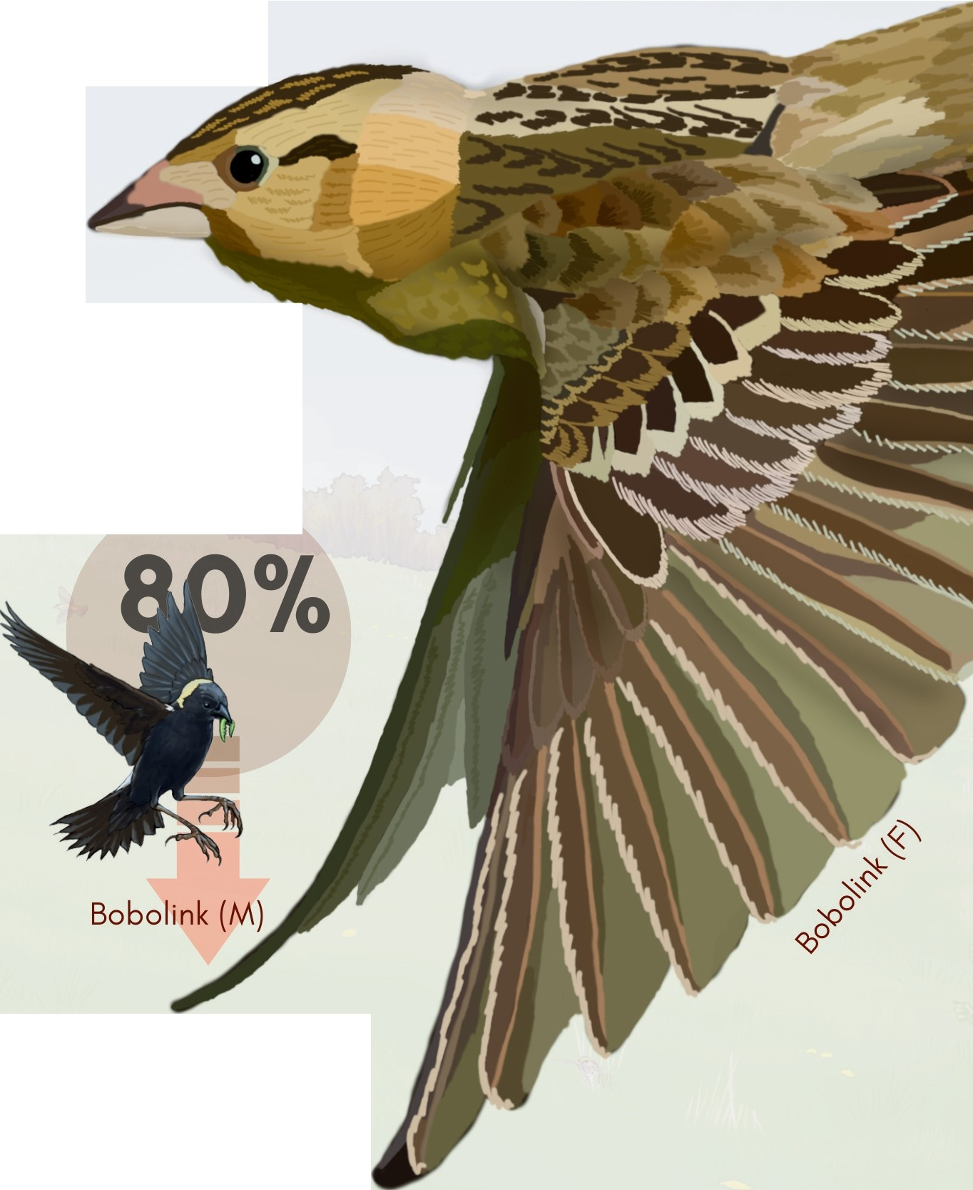Bird species that nest exclusively in grassland are an important part of Ontario's biodiversity. These migratory

species nest in Canada and the USA, and winter in the south. The majority of grassland bird nesting habitat

in Ontario occurs in

grass-dominated hayfields and pastures on farms.

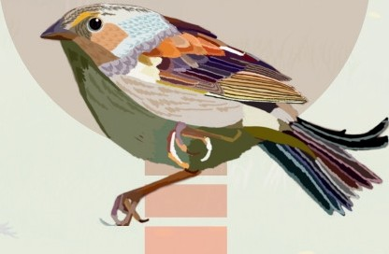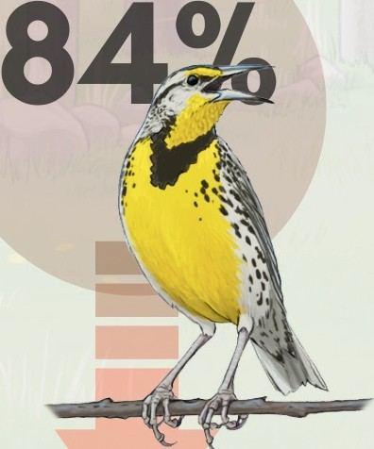***79%***

Eastern Meadowlark Grasshopper Sparrow

Over the past 50 years, grassland bird populations have declined markedly in Ontario and across North America. All three species above are listed as at risk.

Because grassland birds build their nests directly on the ground, nests are vulnerable to trampling by livestock, destruction by farm machinery, and exposure to predators after heavy grazing and hay harvesting.

BBird Ecloloogy &

Conservation Ontario

* LEARNMORV

grasslandbirds.ca

©{2024}BECO

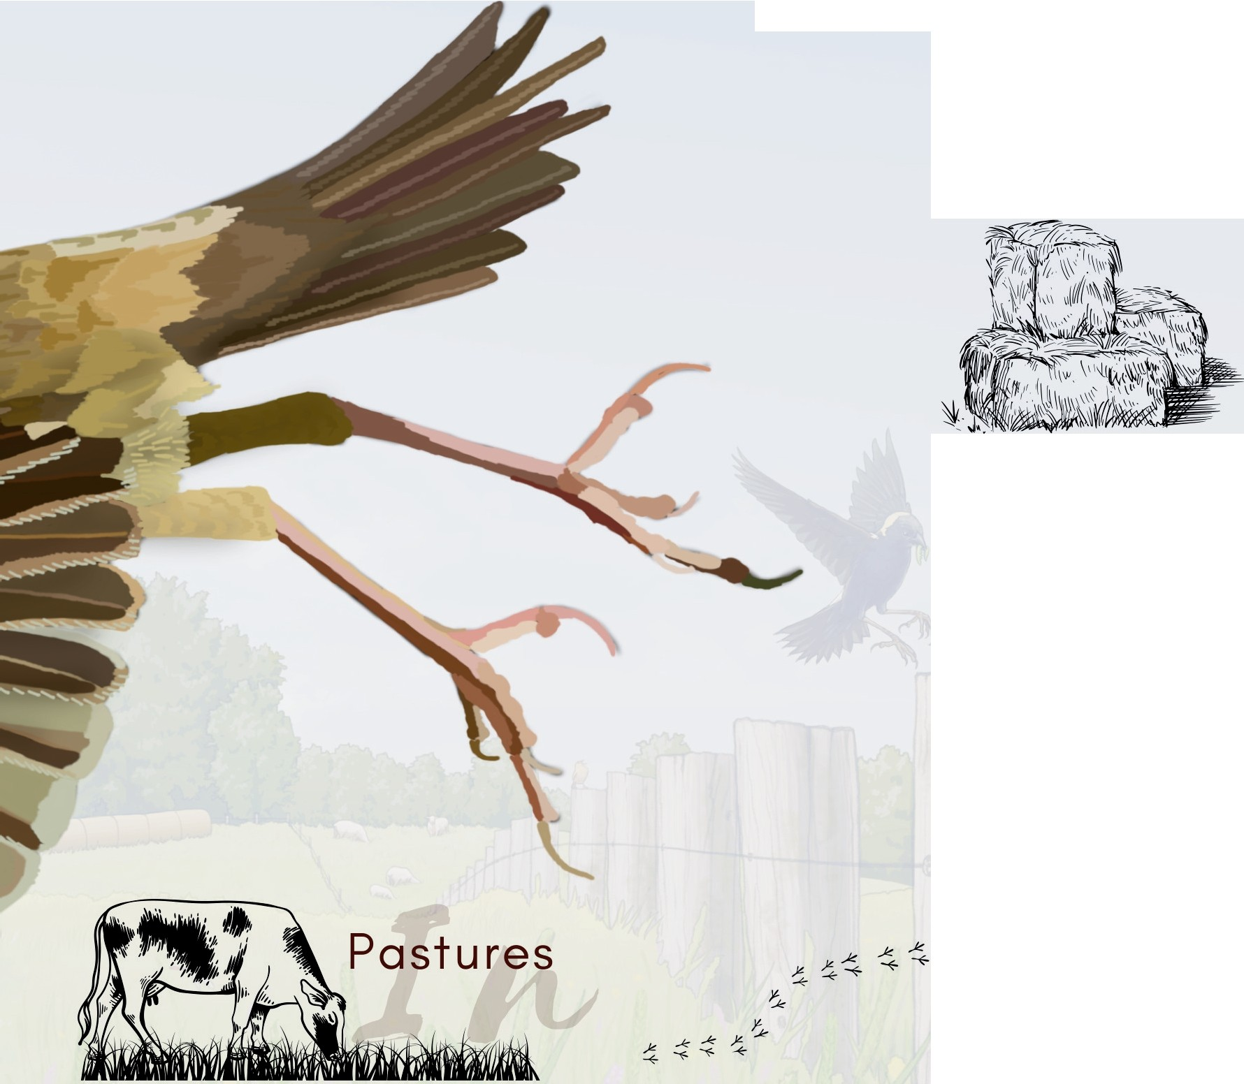**Conservation on Farms**



Hayfields

Delay haying until **mid-July** or later Alternatives:

## Delay as long as possible, even early July is better than mid-June

## Cut perimeters first, delay interior cut

* + Cut fields with high bird abundance last
  + Cut large fields last

Delay grazing until **mid-July** or later in areas with the most nesting birds

# Alternatives:

## Delay as long as possible, even early July provides some birds a chance to raise young

* Light spring grazing from late May to beginning of June, then rest paddock until mid-July (Bobolink will stay and renest if enough vegetation remains)
* Lengthen rest period between grazing occasions to at least 40 days (if vegetation is short after grazing, bobolink will disperse, but eastern meadowlark and grasshopper sparrow will stay and renest.
* Reduce grazing pressure during peak nesting

I• **peak nesting**I

•

-- 1 •

**4E** - - - - - - - EasternMeadowlack •

'-b

reed·1ng

'Lmigration

-- Grasshopper Sparrow ------

***'i*** ·- Bobolink ------

J